LAB 4
NGUYỄN MINH QUÂN – ITITIU23035

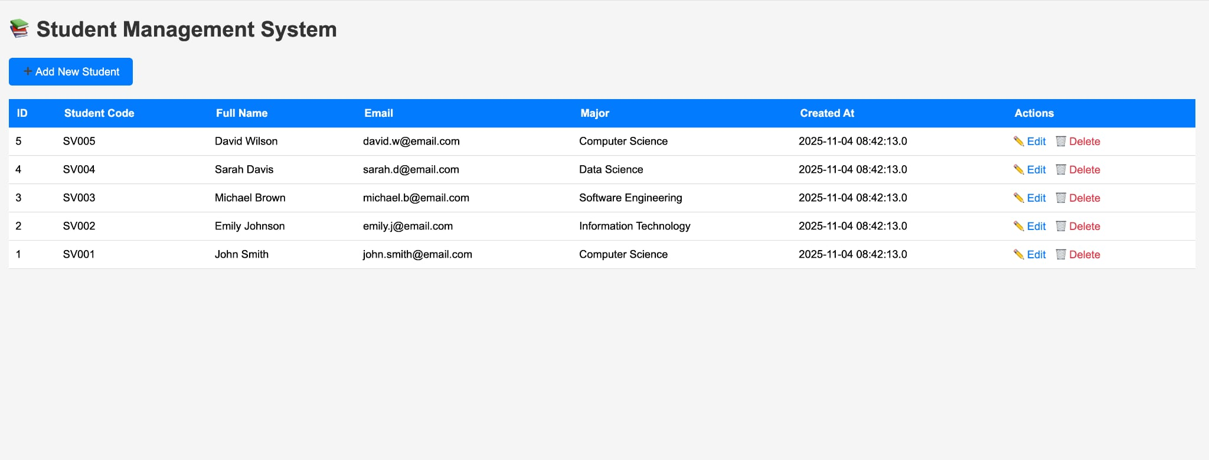
Main interface (list_students.jsp)
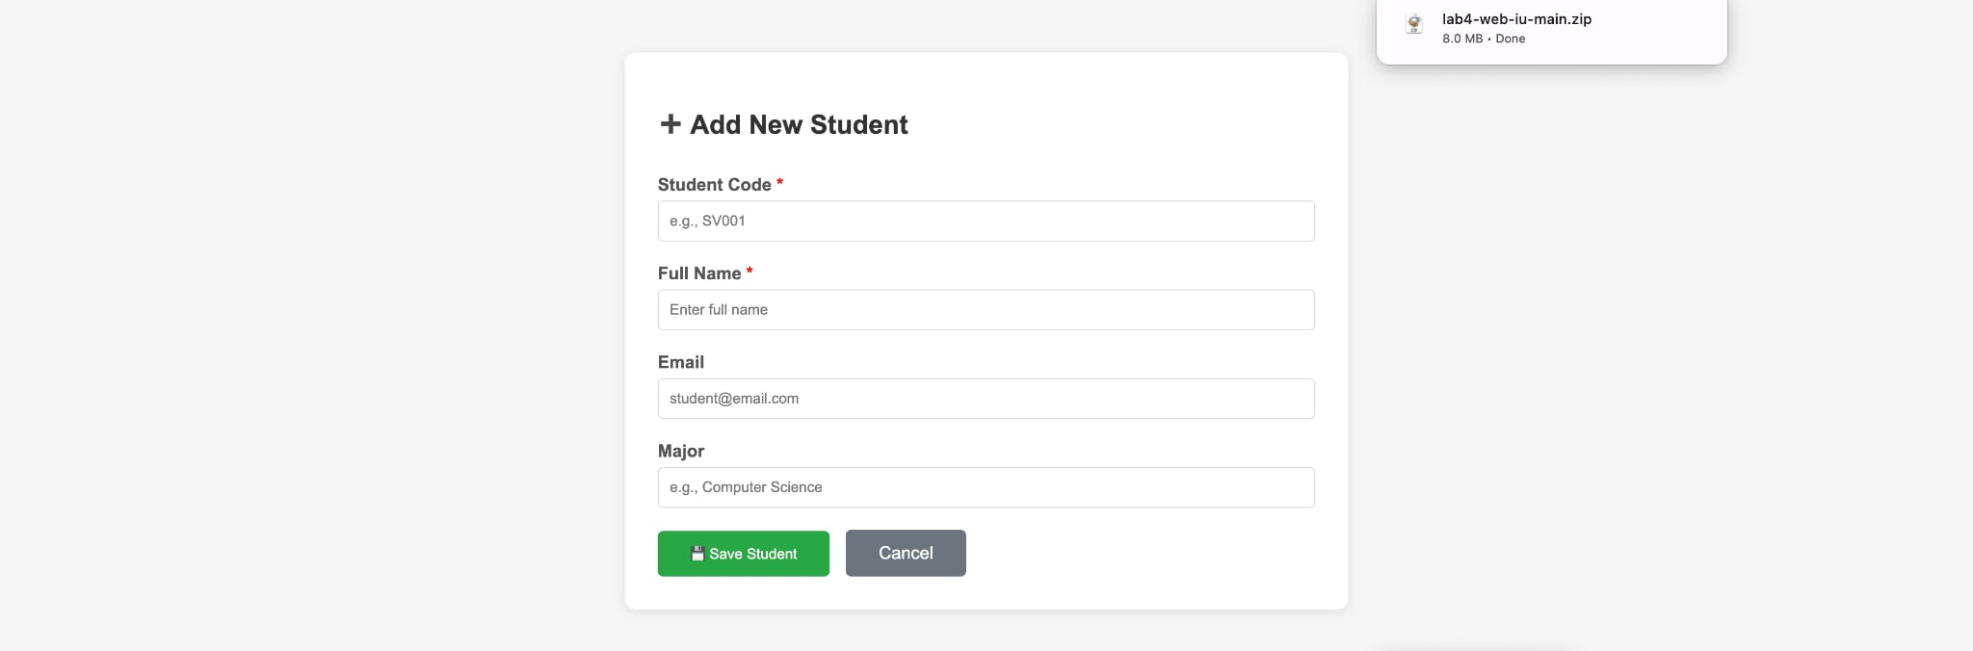
Add new student (add_student.jsp)
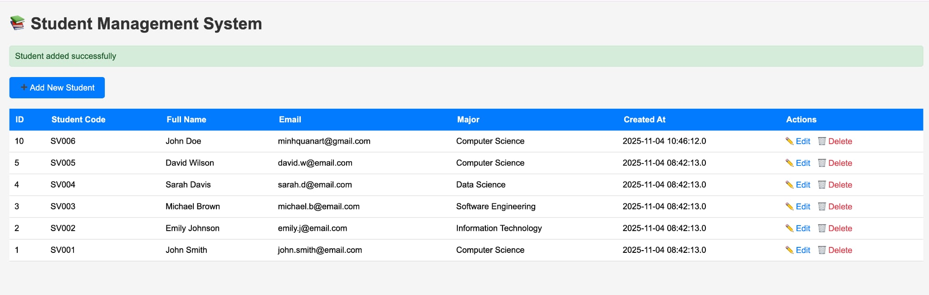
Test 1: Input Fullname: John Doe, code SV006
Output: Successful
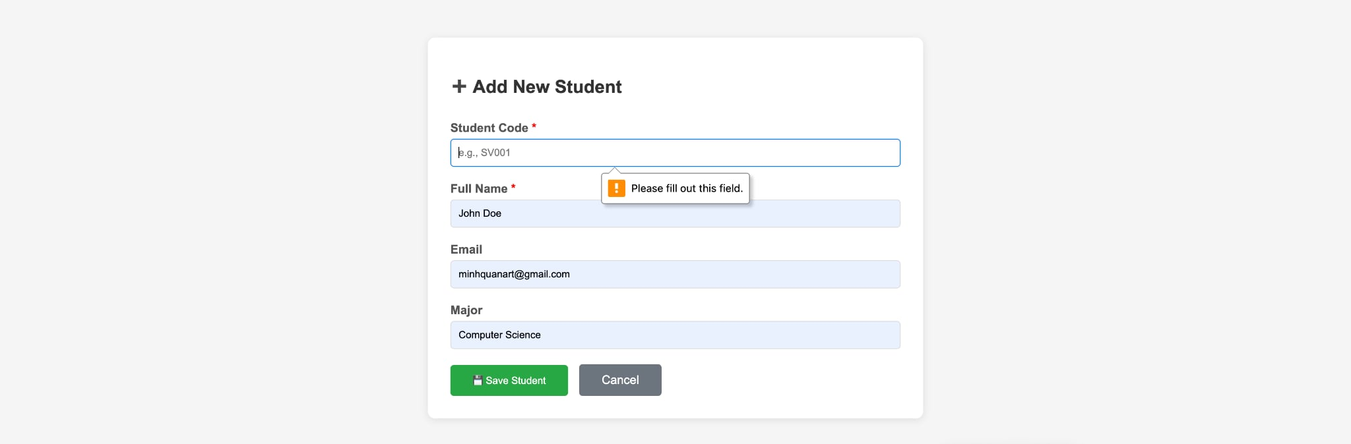
Test case 2: Input already exist information
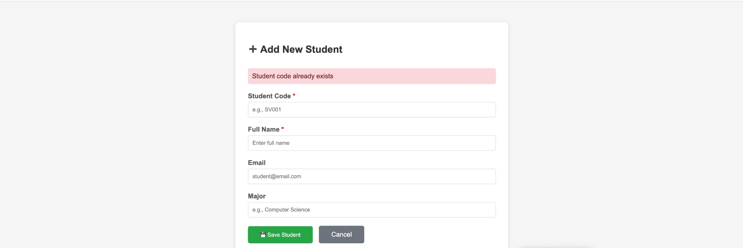
Result: Announce error
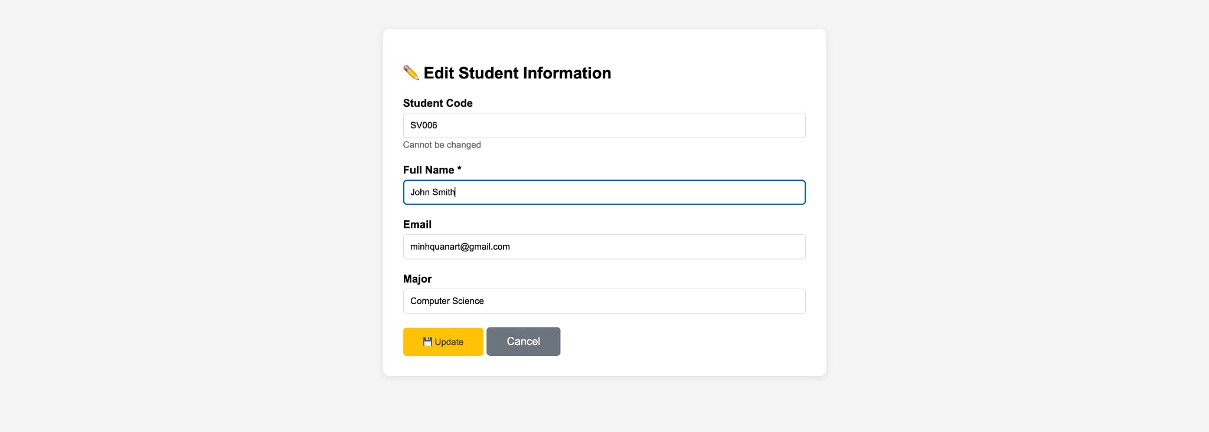
Test case 3: Edit information
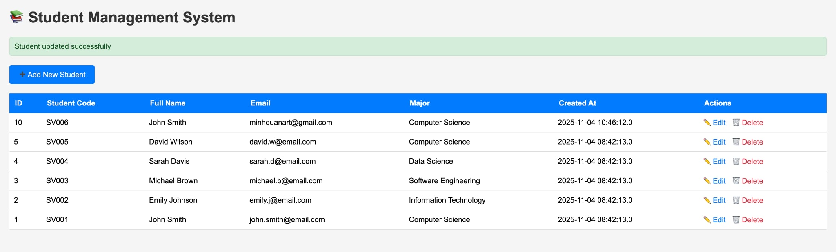
Result: Successful
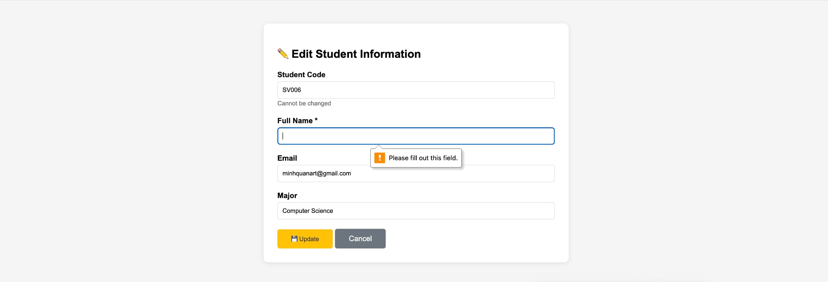
Input: Access adit page with id 999
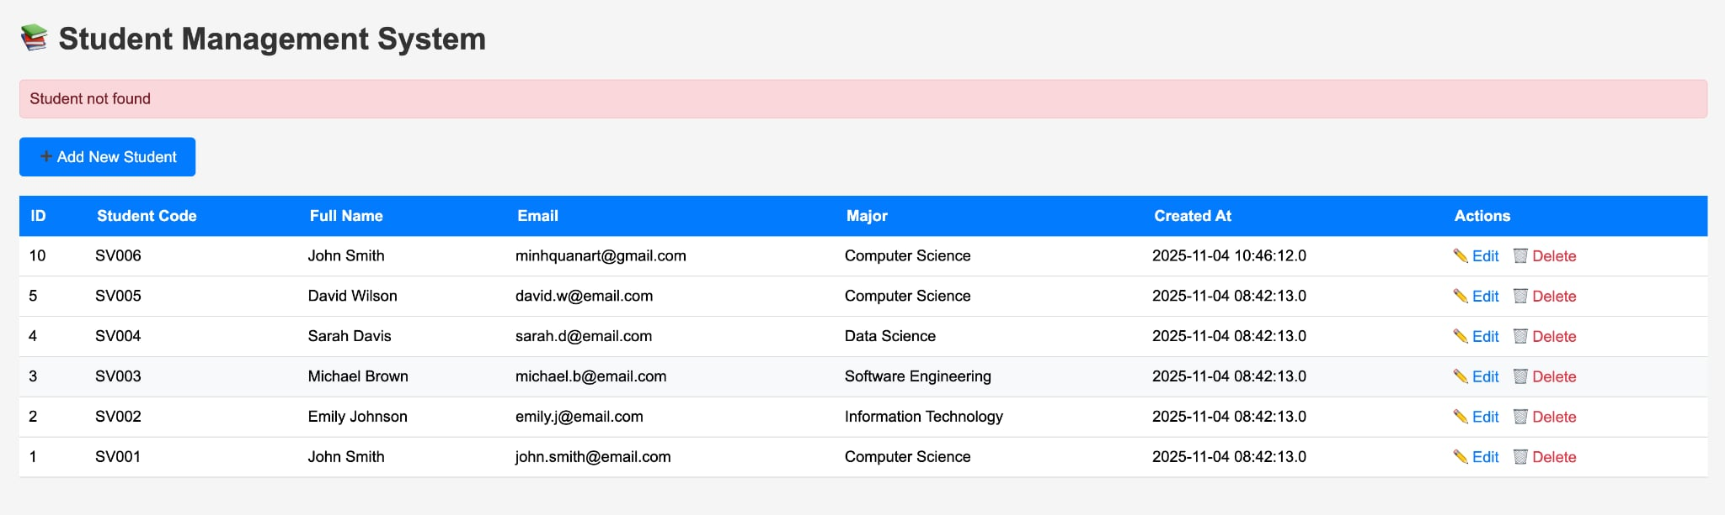
Result: Can’t find the student
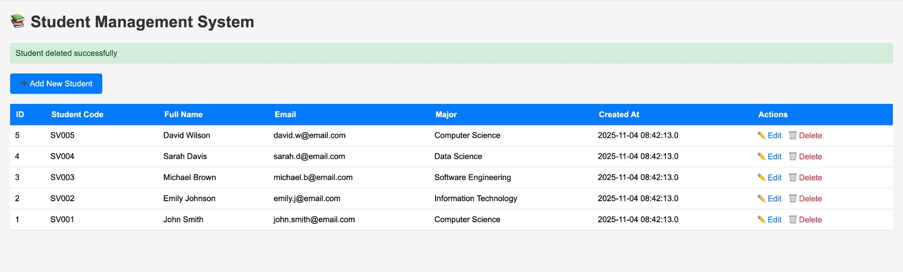
Delete student

